**Thread Management using POSIX Library - Detachment and Cancellation assignments**

Mandatory

1. Write a program to create 3 threads with the detach and cancel status as below.

|  |  |  |  |
| --- | --- | --- | --- |
| Thread# | Detached (Y/N) | Cancel type | Cancel status |
| 1 | Y | PTHREAD_CANCEL_DISABLE |  |
| 2 | N | PTHREAD_CANCEL_DISABLE | PTHREAD_CANCEL_DEFERRED |
| 3 | N | PTHREAD_CANCEL_ENABLE | PTHREAD_CANCEL_ASYNCHRONOUS |

a. Let all the threads read and display their detach, cancel type and status and then display thread specific message as below.

T1: Display message in the format as below every 2 secs

<timestamp> Health OK

T2: Print numbers starting from 1000 in steps of 2 at an interval of 3 secs in format as below.

<timestamp> <threadid> <countvalue>

T3: Print numbers starting from 2000 in steps of 2 at an interval of 3 secs

<timestamp> <threadid> < countvalue

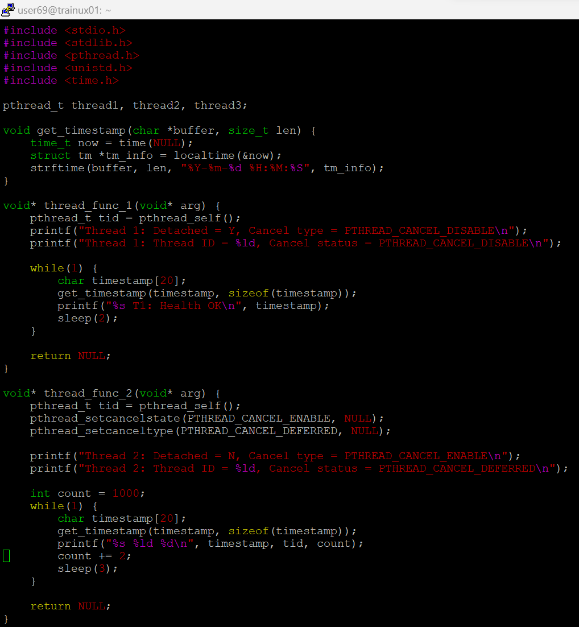

b. After creating threads, and after 3 minutes from main(), cancel all 3 threads

c. From an other terminal, use command below to view the thread count of your program

ps -eLF

top

[For top command usage to refer https://www.golinuxcloud.com/check-threads-per-process-count-processes/ ]

d. What difference did you observe between top and ps command?

A. top should be used to see which processes are most active, ps could be used to see which processes are running currently.

e. Which column shows the number of threads in ps and in top commands?

A. In ps -eLF, the NLWP column shows the number of threads.

In top, the THR column shows the number of threads for each process.

f. Which thread was cancelled first and why?

Thread 3 is canceled first because it uses PTHREAD_CANCEL_ASYNCHRONOUS, meaning it is canceled immediately

g. Were all 3 threads cancelled? Justify the observation

Yes, all threads were canceled. However, Thread 3 was canceled immediately. Thread 2 was canceled after the sleep, and Thread 1 was canceled but since it was detached, it might not have been joined